**Week 4 Task Report: Dashboard Creation for Sentiment Analysis**

**Enrolment: 21CS002377**

**Name: Gudapelly Shrihari**

**Branch: CSE (AI & ML) [Batch 2]**

**Objective:**

The objective was to create an interactive dashboard in Power BI to visualize the sentiment analysis results. This included generating various charts and plots to present the data in a comprehensive manner.

**Importing CSV into Power BI**

* Data Import: Imported the CSV file into Power BI to create visual representations of the sentiment analysis data.

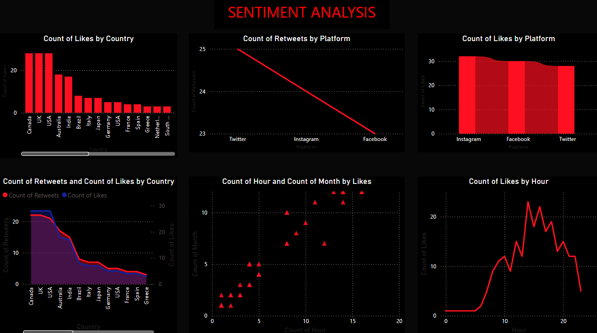

**Conclusion**

In Week 4, an interactive and informative dashboard was successfully created in Power BI. The dashboard includes various visualizations to provide a comprehensive view of the sentiment analysis data. This enhanced the ability to derive insights and making the data more accessible and understandable for users. The integration of these tools demonstrates a robust workflow from data processing to visualization.